Short and Sweet Ceremony
(Non - Religious)
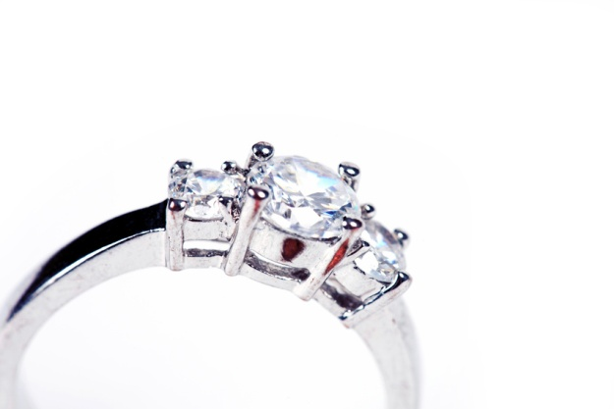

Approximate Time: 8-10 minutes
With music, entrance & exit: 15-20 minutes

Short and Sweet Ceremony
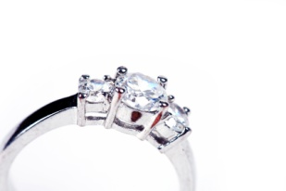

Announcement

Good Evening – before we begin I would like to ask anyone with cell phones to please put them on silent during the ceremony. You are welcome to take pictures, but please no flash photography. Please be seated.
Welcome
Officiant: We are here today to celebrate the miracle of Love. GROOM (full name) and BRIDE (full name) have found that miracle in each other, and now desire to share their love all the days of their lives.
Consent
Officiant: Are both of you willing to give your hand to the one whose heart you hold?
(Both answer): Yes, we are
Officiant: Who presents BRIDE to be married to GROOM?
(The Escort shall say): Her Mother and I or We do or Her Family or other (Bride gives bouquet to Maid of Honor)
Address and Readings
Today you are giving yourselves to one another to love and to live. Your lives are being woven together, and in time, they will intertwine in such a way that you truly will become one in heart, mind and soul. Listen to these words that reflect this kind of love.
Insert reading of choice: ________________
GROOM and BRIDE, may this kind of love always help you keep the promises you are about to make today.
Wedding Vows
(Read to each other) (BRIDE/GROOM) , my promise to you is but a simple one. I will love you today and everyday that follows until the end of time. With the passing of every minute, my love grows stronger and my devotion grows deeper. I will love and cherish you until my eyes can no longer see your beauty, my ears can no longer hear your loving words, and my hands can no longer feel your tender caress. From this moment until my dying breath, you are my love - you are my life. (Wedding Vow #6)
Explanation of the Rings
The wedding ring is the outward and visible sign of an inward and spiritual bond that unites two loyal heart in endless love. May these rings always remind you that it was love that brought you together, and it is love that will keep you together through all the seasons of your lives.
Ring Exchange Vows
Officiant: May I have the token of Groom’s love for Bride? (Once received, hand ring to Groom)
Officiant: Groom, please repeat after me
Groom: Bride, this ring is the token of my love. / I marry you with this ring, /with all that I have and all that I am.
Officiant: Bride, please repeat after me
Bride: Groom, I will forever wear this ring/ as a sign of my commitment/ and the desire of my heart
Officiant: May I have the token of Bride’s love for Groom? (Once received, hand ring to Bride)
Officiant: Bride, please repeat after me
Bride: Groom, this ring is the token of my love. / I marry you with this ring, /with all that I have and all that I am.
Officiant: Groom, please repeat after me
Groom: Bride, I will forever wear this ring/ as a sign of my commitment/ and the desire of my heart
Lighting of Unity Candle
(or other optional Wedding Tradition)
The lighting of the Unity Candle symbolizes the joining together of your two hands, your two hearts and your two lives into one. From this moment on, the light of your love burns jointly as you walk down life's pathway together. May the path of life become brighter as the flame of your love grows stronger.
Wedding Prayer/Blessing
May God bless you with Hope enough to keep sunshine in you love, and Fear enough to keep you holding hands in the dark; Unity enough to keep your roots entwined, and Separation enough to keep you reaching for each other; Harmony enough to keep romance in your song; and Discord enough to keep you tuning your love so it becomes sweet music to all who may hear it. (Blessing #3)
Pronouncement/Kiss/Presentation
GROOM and BRIDE, now that you have shared with each other these words of love and commitment, and we have witnessed the expression of your love as you have given each other these rings, and you have joined hands and hearts before your family and friends, it is with great joy I pronounce you husband and wife.
Officiant: GROOM, you may kiss your Bride.
(Bride receives bouquet from Maid of Honor)
Officiant: Ladies and Gentlemen, it is my privilege and honor to introduce to you for the very first time, Mr. & Mrs. ____________.

